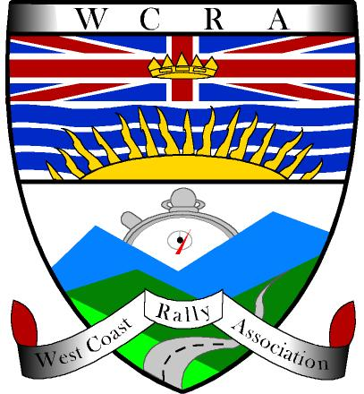 WEST COAST RALLY ASSOCIATION
Please fill in and save a copy of this entry form. Email copy to darsi@ rallybc.com, then print and sign form and mail with cheque to WCRA, 1169 Nelson St #408, Vancouver BC, V6E 1J3 Emailing the form gets you on the list. The cheque or online payment makes it a confirmed entry.
2014 Heart of Darkness
ENTRY FORM

DRIVER | NAVIGATOR
Name: | Name:
Address: | Address:
City/Prov/Code: | City/Prov/Code:
Telephone: | Telephone:
Email: | Email:
Emergency Contact Name: | Emergency Contact Name:
Emergency Contact Phone: | Emergency Contact Phone:

Preferred Method of Communication: Email Phone Mail

Check all that apply

VEHICLE INFO
Make: |  | Model:
Year: | Colour: | License Plate: | Driver’s License No:

Class:
Novice Unlimited Calculator Paper Historic

Preferred Starting Position:
1-10 11-20 21-30

Comments:

Fees: please make all cheques payable to West Coast Rally Association.
- $90 ($90 US) up to June 14th, 2014 – less $5 for each member of WCRA (up to 2 per team)
- $100 ($100 US) after June 14th, 2014 – less $5 for each member of WCRA (up to 2 per team)

Check here and add $10 if you want a second copy of the routebook

Please send entries to:
I am the registered owner of the above vehicle and authorize the use of it in this event.

_________________________________ ____________________________________
PRINTED NAME SIGNATURE
Novice Rally
1169 Nelson St #408
Vancouver, BC
Canada V6E 1J3

