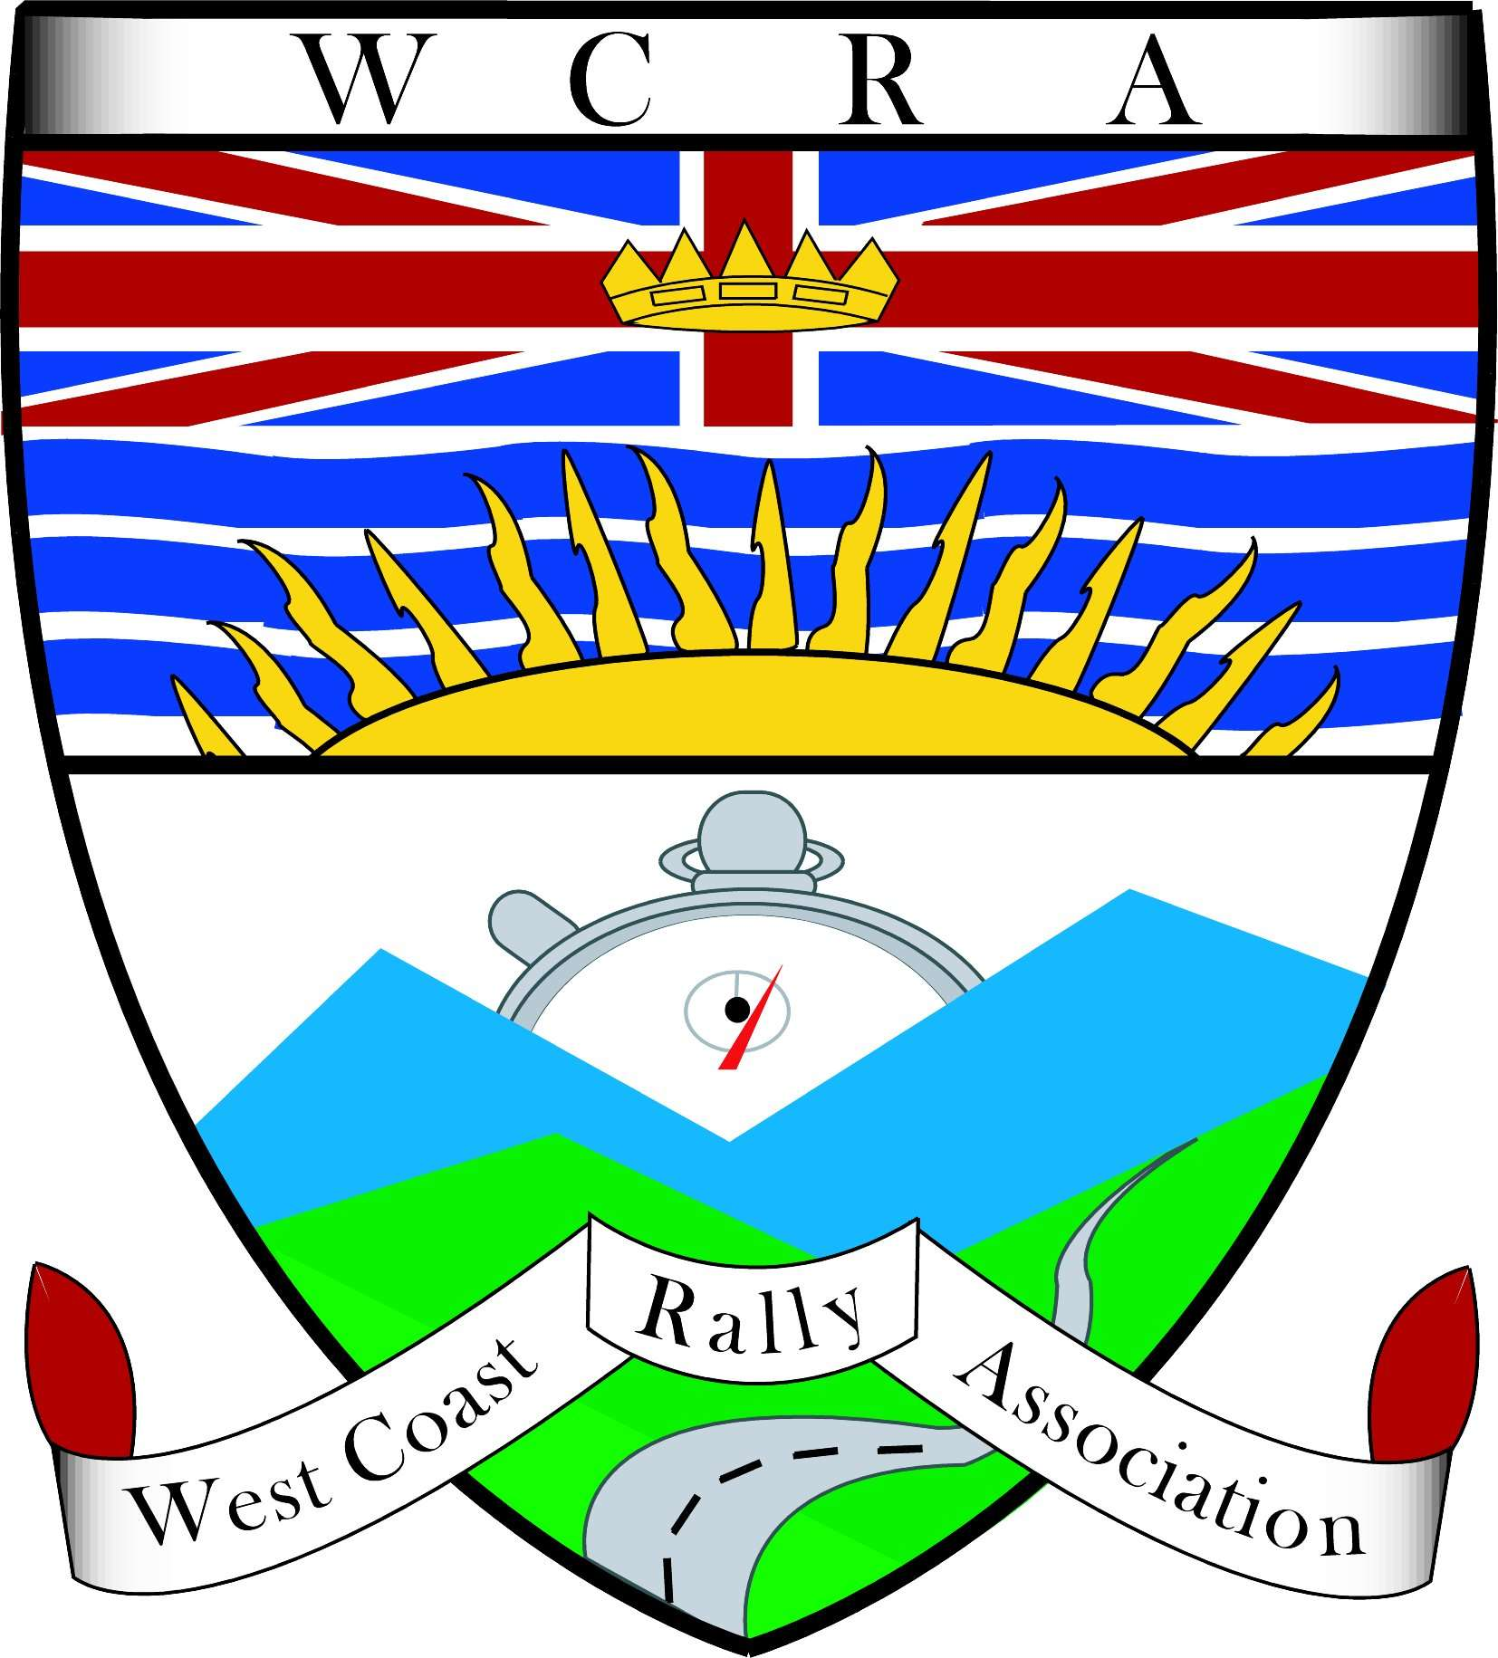 | 2014 WCRA Rallycross Series – Entry Form  Submit pre entry to:  kristin@rallybc.com

PLEASE COMPLETE ALL THE REQUIRED FIELDS
Driver’s Name |  | Phone
Address |  | Email
City | Province/State | Postal Code
Club | Drivers License #: | Drivers License Province/State
Vehicle Year/Make/Model |  | Color
License Plate # | Province
Class (see Supplementary Regulations for details):
Street Tire Traction Tire Competition Tire
Drive Type: 4wd 2wd

Novice: Yes No

Do I need a competition license? (Single Day or Basic or CARS / NASA / RA rally license is required) | No |  | Yes | Total
 | License # |  | Single Day $10
 | License # |  | Or:
 | License # |  | RPM Basic (yearly) $25
Event Entry Fee | Non-Member  $40 |  | RPM Club Member (WCRA,IRC,STSRC)  $30
Add up all the checked boxes…. |  |  | TOTAL AMOUNT
WCRA Club Memberships are available at Registration or go to www.rallybc.com
For event details contact Kristin@RallyBC.ca
Make cheque or money order payable to: “WCRA”
You will be required to sign a waiver at the event before participating.

